INSTRUCTIONS FOR ONLINE GIVING REGISTRATION
- Log in to Church website: www.buffalobaptistchurchofshelby.com
- Click the “Online Giving” link. This will direct you to Easy Tithe.
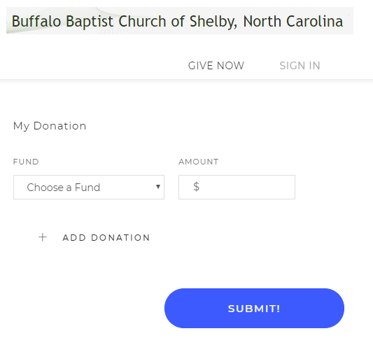
- Click “Sign In.”
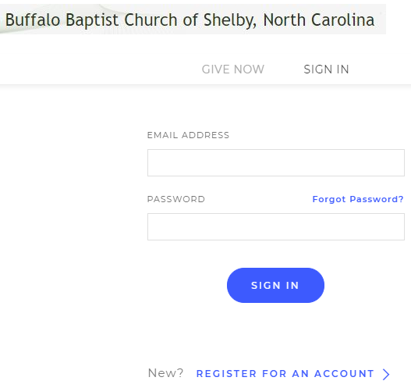
- Click “REGISTER FOR AN ACCOUNT”
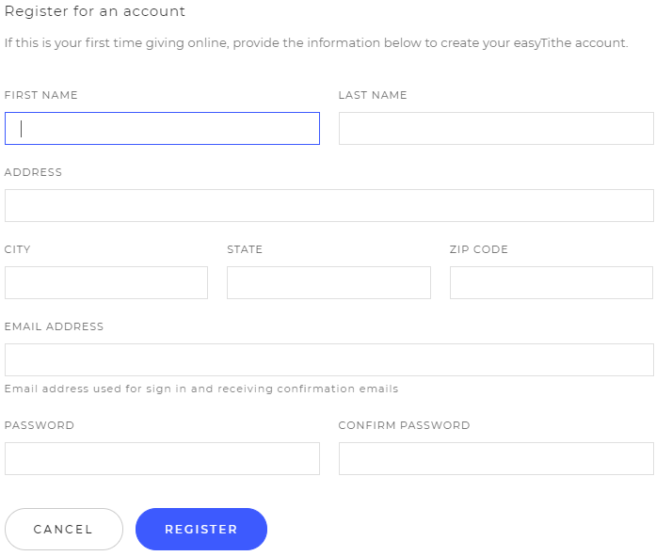
- Click “REGISTER” when finished. Then choose Account in the drop-down list.
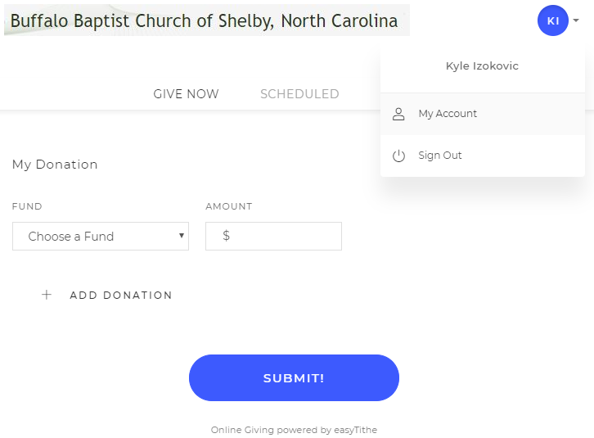
- Click “Payment Methods” then “Add Payment.”
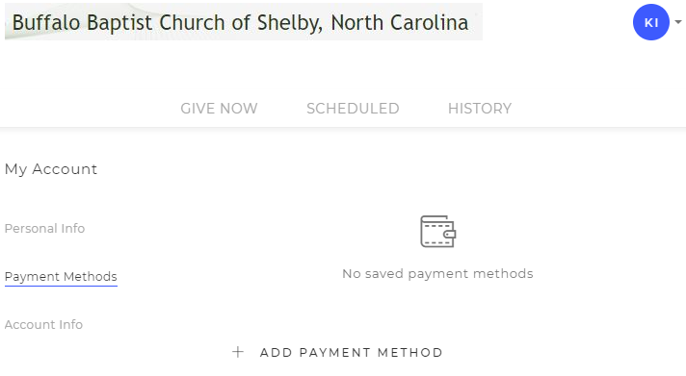
- Fill out payment information and click “Save.”
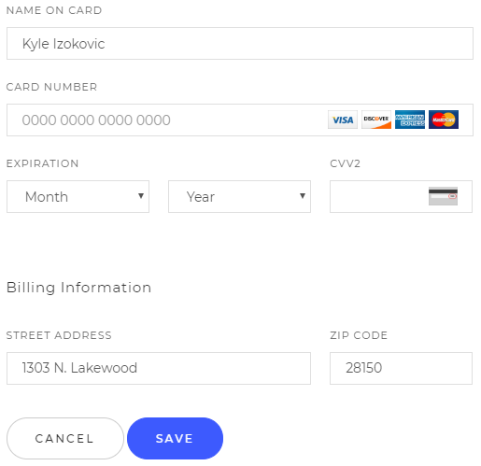
- Go back to the “Give Now” page.
- You can now choose a fund to give to:
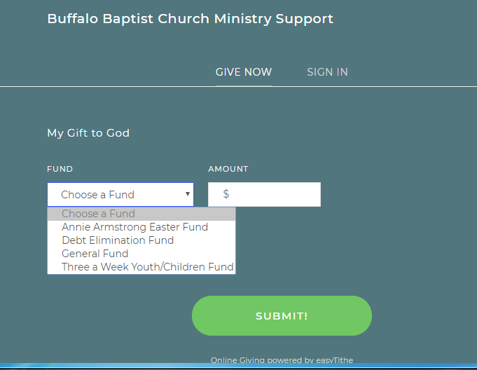
- BE SURE TO CLICK THE BOX FOR RECURRING PAYMENT. This will make an automatic payment each pay period as you define. Some may pay weekly and some monthly. You will need to make separate entries for each fund.

